1. **Write an assembly language program to swap two 8-bit datausing 8085 processor.**

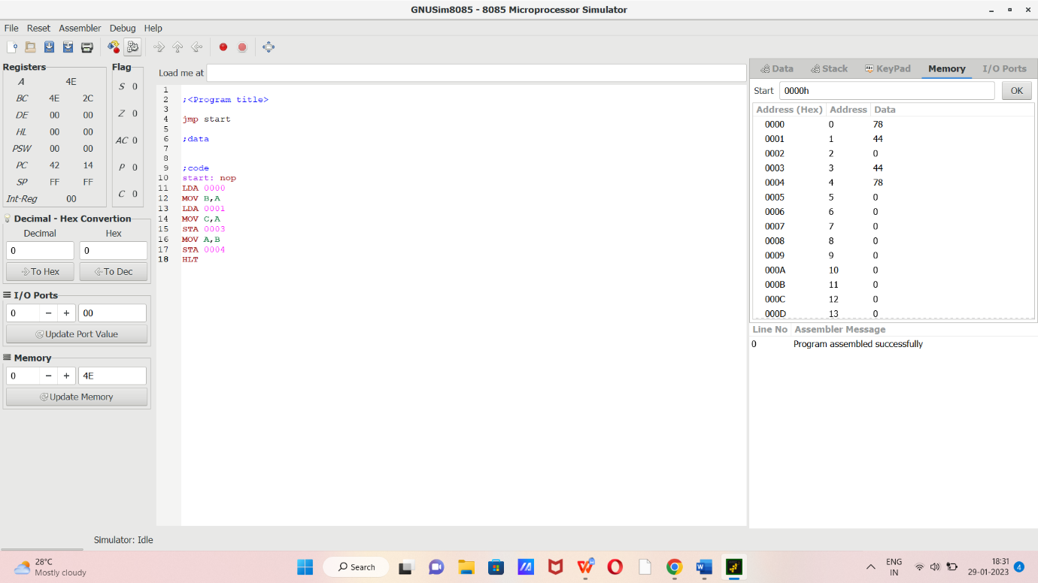

1. LDA 0000
2. MOV B,A
3. LDA 0001
4. MOV C,A
5. STA 0003
6. MOV A,B
7. STA 0004
8. HLT